**Azure portal/ Search > App Registration**

1: In the Search Box type: App Registration

2: Click Add

3: Add the URI as seen below (pingpong is just a name, has no presence in code base)

4: Tick Implicit Grant Flow: “ID Token”

**(Example: SingleSignOn using OAuth/Org Active Directory) as Azure AD**

**–**

**Multi-Tenant – Any Organization**

It worked With Hotmail/live or any Org AD

For **MFA** (Multi Factor Authentication) – you will require “Azure AD Premium”. This MFA comes under Azure Active Directory > Security > Conditional Access

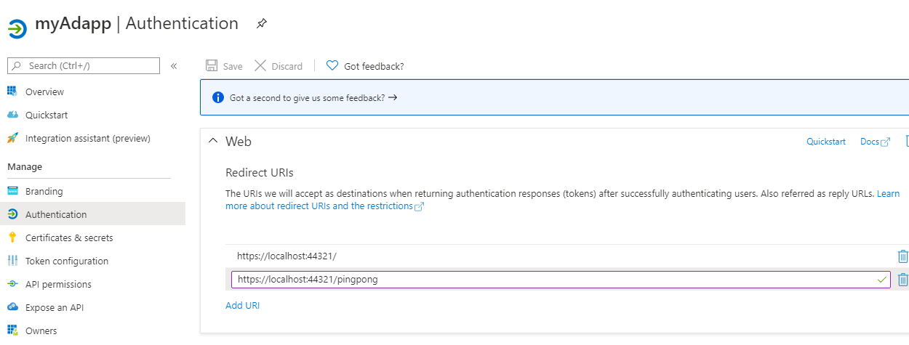

**[Look @ /pingpong]**

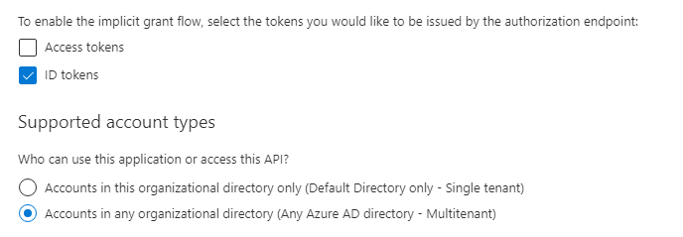

**It has no practical page(pingpong), however have to be same as in** CallbackPath **below:**

**appsettings.json**

{

"AzureAd": {

"Instance": "https://login.microsoftonline.com/",

"Domain": "[Enter the domain of your tenant, e.g. contoso.onmicrosoft.com]",

"TenantId": "XXX-d636-XXX-9d5f-XXX",

"ClientId": "XXX-XXX-4361-8854-XXX",

"CallbackPath": "/**pingpong**",

"SignedOutCallbackPath ": "/signout-callback-oidc"

},

"Logging": {

"LogLevel": {

"Default": "Information",

"Microsoft": "Warning",

"Microsoft.Hosting.Lifetime": "Information"

}

},

"AllowedHosts": "*"

}

**launchSettings.json**

{

"iisSettings": {

"windowsAuthentication": false,

"anonymousAuthentication": true,

"iisExpress": {

"applicationUrl": "https://localhost:44321",

"sslPort": 44321

}

},

"profiles": {

"WebApp_OpenIDConnect_DotNet": {

"commandName": "Project",

"launchBrowser": true,

"applicationUrl": "https://localhost:44321;http://localhost:3110",

"environmentVariables": {

"ASPNETCORE_ENVIRONMENT": "Development"

}

}

}

}

**Get The Access Token:**

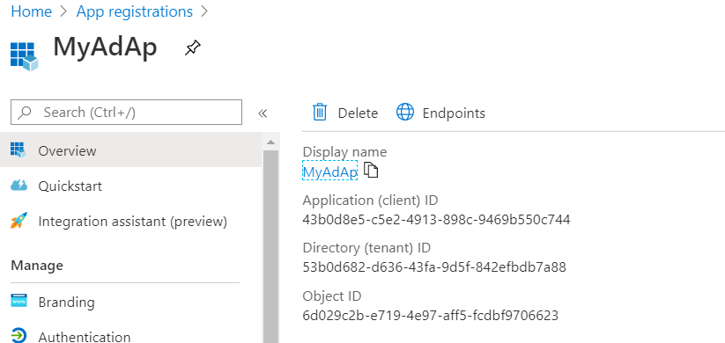

Use it in \appsettings.json file above

Your Controller code goes as:

[Authorize]

public class HomeController : Controller{}



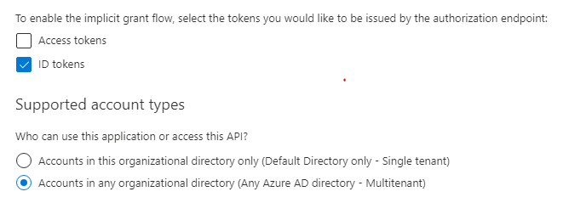

Note:

This works with Multi-Tenant (Hotmail/Live Account or Org AD) –

You can login with Hotmail

You can login with Org Active Directory

(To login with Org AD, need some more settings in Portal, as following)

1: Go to Portal Home Page

2: Search “Azure Active Directory’ in the blade or search Box

3: In the Menu, Click Users (Under Manage)

4: See list of user and account who can access the App with OPID

5: If your Org ID is not there, you need to create/add one here

**Add process:**

1: Click User > New Guest User > Invite User

2: Put your org email ID to invite

3: Click Send

4: This email id will receive invitation, accept it in email

5: Come back here and refresh

[The invited user will appear here]

Now Try Login with Org Active Dir/AD

**Some Errors:**

**1:**

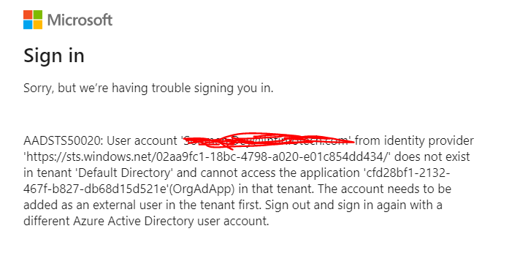

[It is because the user in quote above is not added in Azure Active Directory]

2:

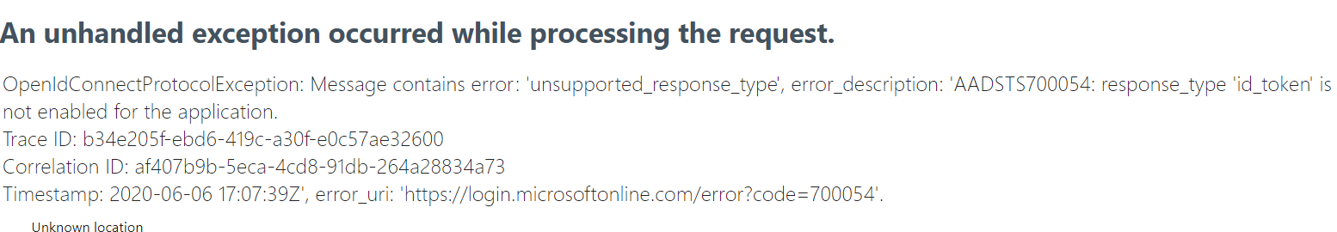

[ID Token must be selected as Implicit Grant Flow for the Application Registration]